Term Project

0711529 陳冠儒

Device: ASUS AI800M PRO

1. Device Information

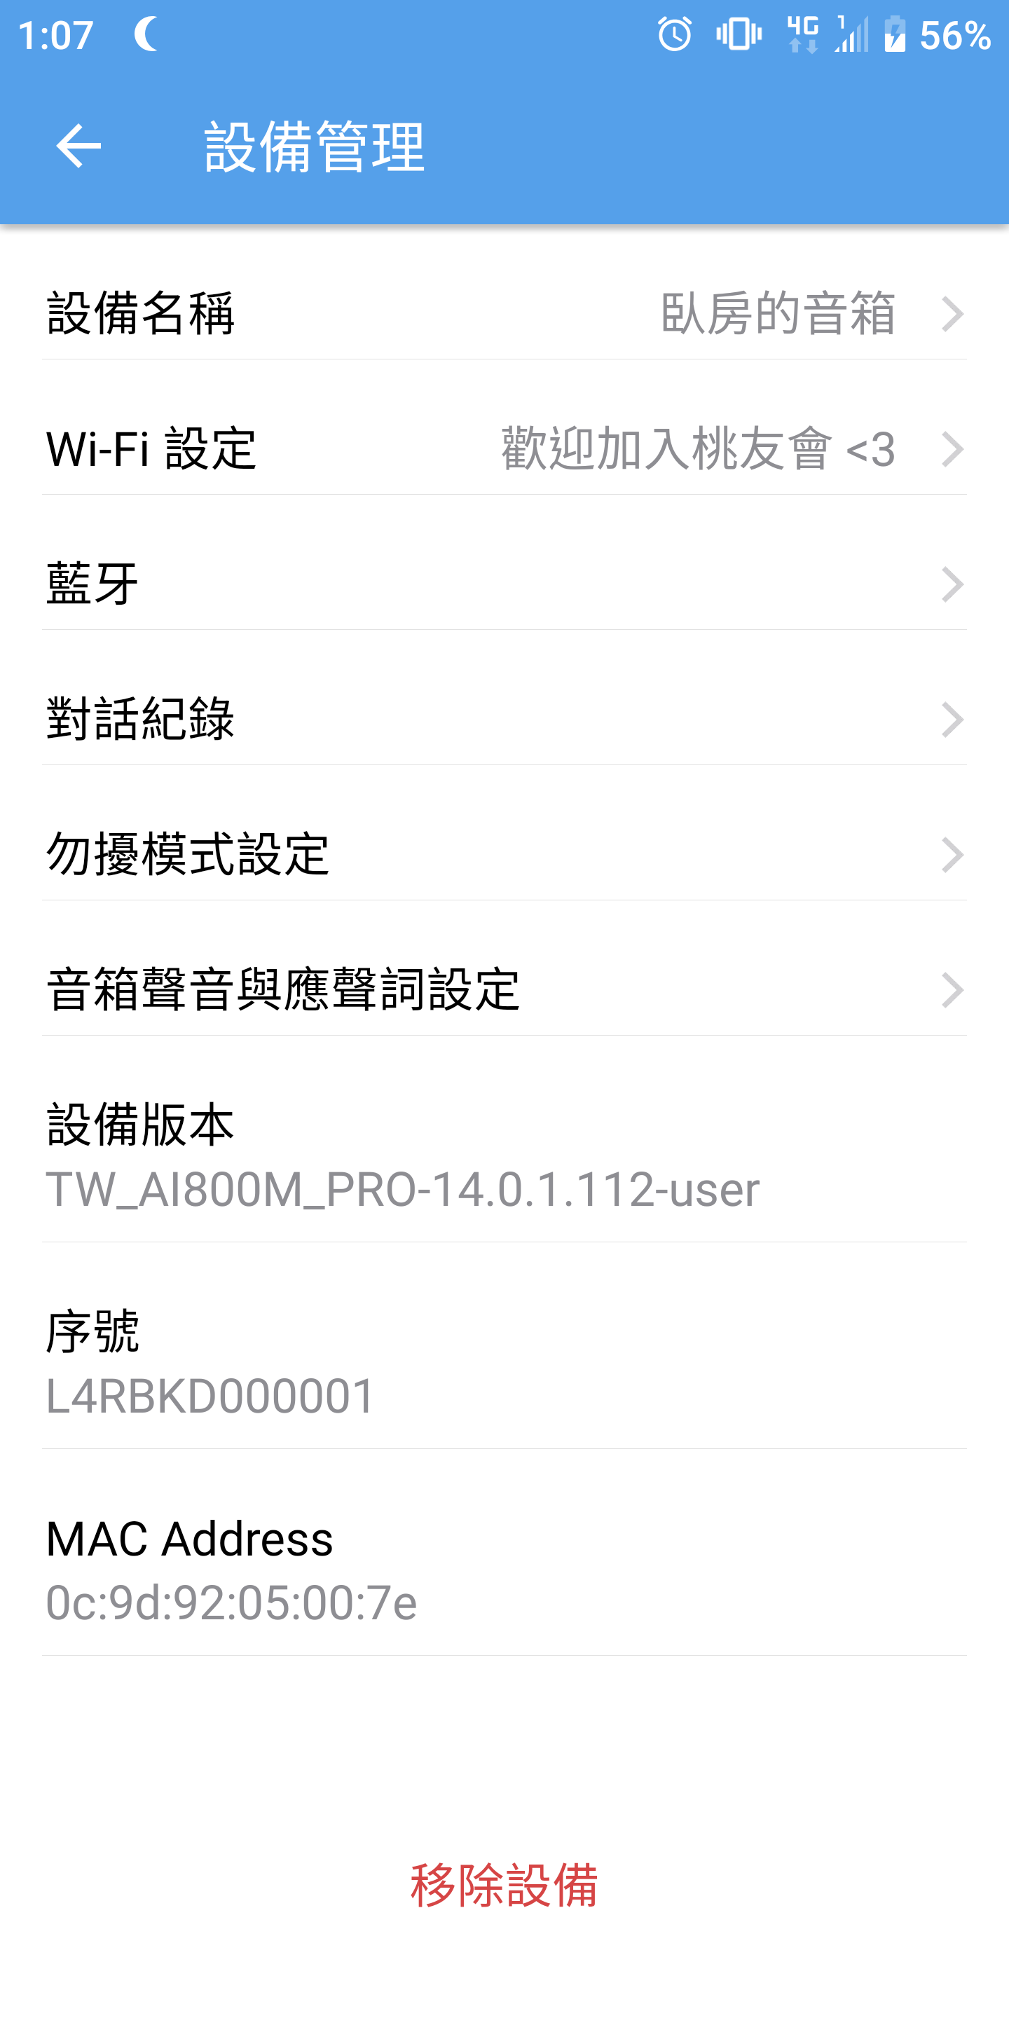

From the app of the IoT device, we can find the mac address of it, 0c:9d:92:05:00:7e.

1. ARP Spoofing

I use my windows 10 as attacker, and the IoT and the attack use the same wi-fi. The attacker IP: 192.168.0.23, attacker mac address: d8-c4-97-c2-cf-f2. The IoT IP: 192.168.0.45 ( get by the ip scanning ), IoT mac address: 0c:9d:92:05:00:7e.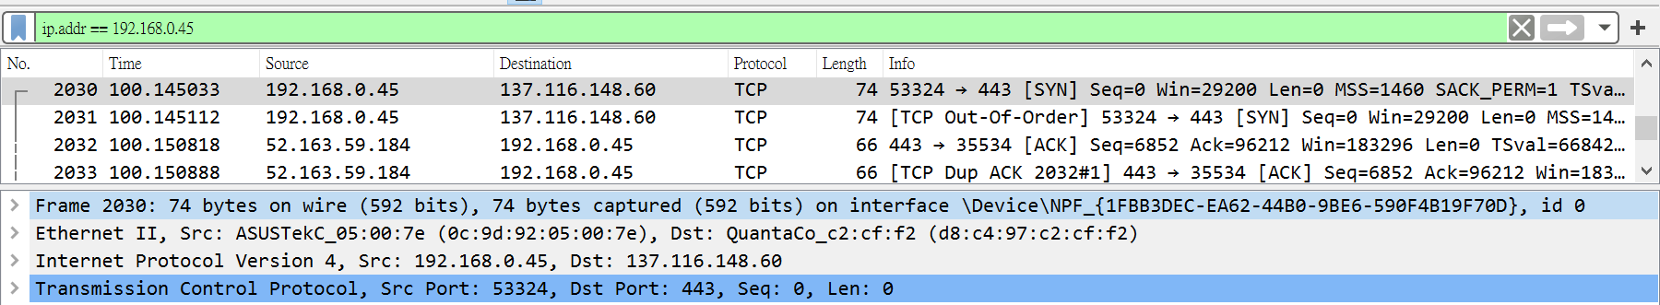

Figure 1. Victim IoT to Attacker

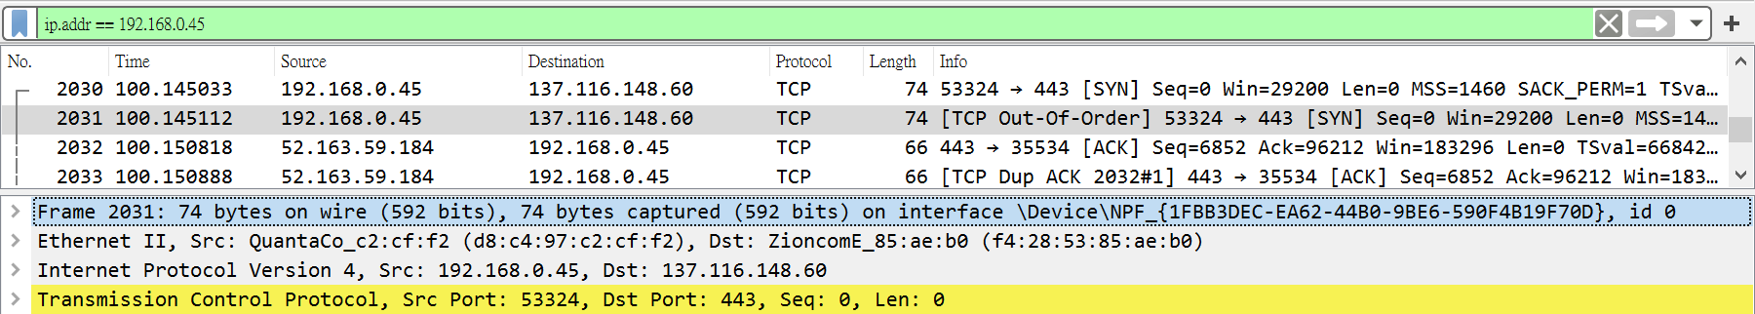

Figure 2. Attacker to AP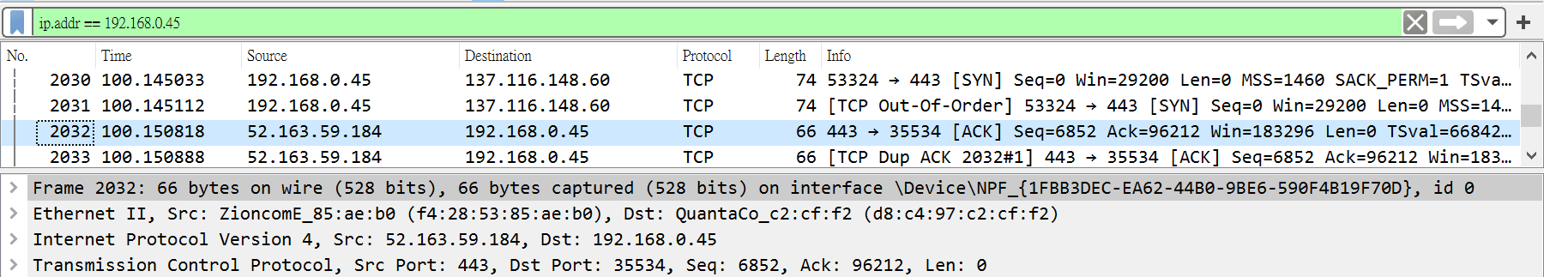

Figure 3. AP to Attacker 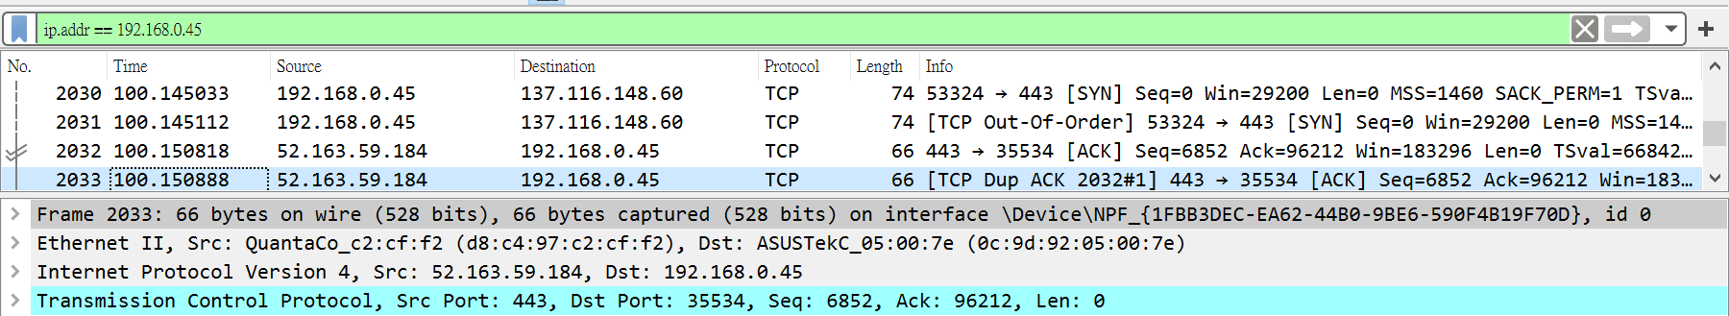

Figure 4. Attacker to Victim IoT

1. MITM Attack

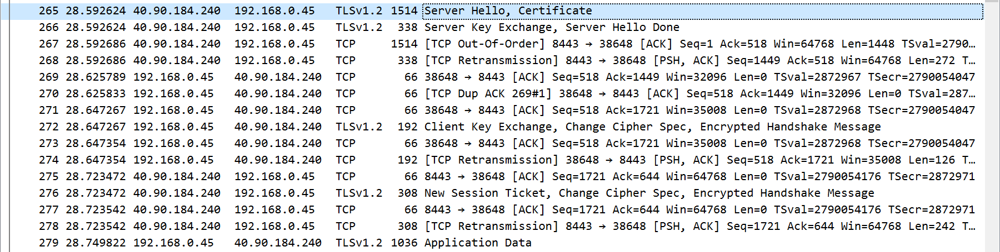

Application data using the TLSv1.2 to transfer, so it’s difficult to do the MITM attack.